EXHIBIT "X"

EXHIBIT X-PAGE 1 OF 3

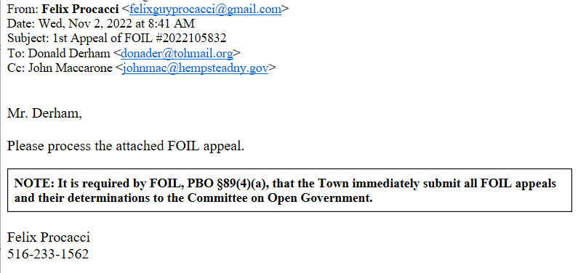

EXHIBIT X-PAGE 2 OF 2

